

Question/Answer Booklet

Name:

PHYSICAL EDUCATION STUDIES
PES GENERAL: Exercise Physiology Test
Working time for paper: 45 mins

To be provided by the candidate
Standard items: pens, pencils, eraser, correction fluid, ruler, highlighter

This paper consists of:
Questions | Number of questions available | Marks available
12 | 12 | 45

Question 1:
- What are the 3 elements of a training session? (3)

Question 2:

When we exercise there are seven (7) circulatory responses. Name and describe 3 responses.
(6)
- _______
- _______

Question 3:
List the two (2) responses of the respiratory system during exercise.
(2)
- _____________________________________________________
- _____________________________________________________

Question 4:
Our body provides energy for movement from the breakdown of ATP. How does the body recreate ATP? In order to answer this question you need to name the 3 energy systems.

- Name the 3 energy pathways in order from quickest to slowest (give approx. time) and give example of sport for each. (3)

- What are the main fuel source for each energy system? (3)
________ ______________________________________________________________________________________________________________________________________________
- Consider a Tour de France cyclist and the training required for this event. Name the energy system the cyclist would develop and name the type of training required for such an event. Use your knowledge of fitness testing to assist you. (2)
__________________________________________________________________________________________________________________________________________________________________________________________________________________________________________________________________________________________________________________________________________________________________________________

Question/Answer Booklet

Name:

PHYSICAL EDUCATION STUDIES
PES GENERAL: Exercise Physiology Test
Working time for paper: 45 mins

To be provided by the candidate
Standard items: pens, pencils, eraser, correction fluid, ruler, highlighter

This paper consists of:
Questions | Number of questions available | Marks available
7 | 7 | 45
 |  | 45

- Fitness is made up of a combination of components, these components of fitness can be categorised into two groups; Health related components and performance related components. In the table below List three (3) Health related components and three (3) performance related components of fitness.
(6)
Health Related Components | Performance Related Components
Cardiorespiratory endurance  Muscular strength  Muscular endurance  Flexibility  Body composition | Power  Speed  Agility  Reaction time  Coordination  Balance

- What are the three (3) elements of a training session? (3)
- Warm up
- Conditioning phase
- Cool down

- When we exercise there are seven (7) immediate circulatory responses. Name and describe three (3) responses.
(6)
Response (1 mark) | Description: one of the following points included (1mark)
Increased Cardiac output | more blood must be circulated to the circulated to the muscle tissue quickly. This is achieved through increased cardiac output Blood flow.  Cardiac output is the amount of blood circulated by the heart in 1 min. Increasing from 5L at rest to 20L during activity.
Increased Heart rate | Heart rate increases to supply more blood to muscles  Increases directly proportional to workload, to a maximum heart rate 220-age.
Increased stroke volume | Amount of blood the heart pumps out in each beat, increases during activity.  More venous blood being returned to the heart from muscles
Increased blood pressure | Increase blood through the arteries increase blood pressure. Systolic pressure increasing.
Increased arteriorvenous oxygen difference | Increasing oxygen consumption in the muscles, increasing during physical activity.  During exercise oxygen used in the muscles increases to 17ml/100ml.
Selective redistribution of blood | During activity arteries open and shut down selectively to direct blood flow away from non-working areas  Blood is redirected to working muscles through dilation and constriction.
Temperature regulation | Transferring heat through the blood to the surface of the skin, released through perspiration.  As heat increases during physical activity heat moves to s

- List the two (2) immediate responses of the respiratory system during exercise.
(2)
- Increased ventilation
- Increased gaseous exchange in the lungs

- There are two (2) pathways of energy production for the human body. On the diagram below fill in the blanks to identify the pathways of energy production.
(4)
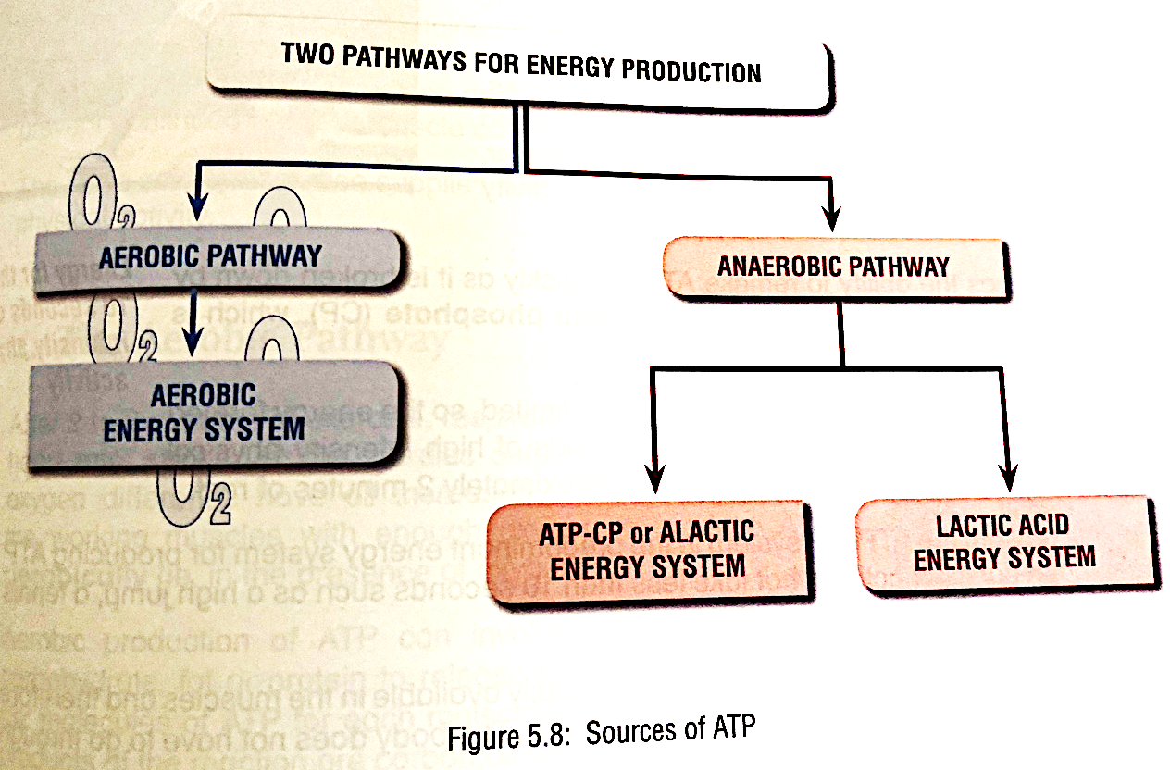
Aerobic Energy System

ANAEROBIC PATHWAY
AEROBIC PATHWAY

Aerobic Pathway

Lactic acid System
ATP-PC System

- Our body provides energy for movement from the breakdown of ATP. How does the body recreate ATP? In order to answer this question you need to name the 3 energy systems.

- Name the three (3) energy systems in order from quickest to slowest, explain two (2) characteristics of each system and give example of sport for each.
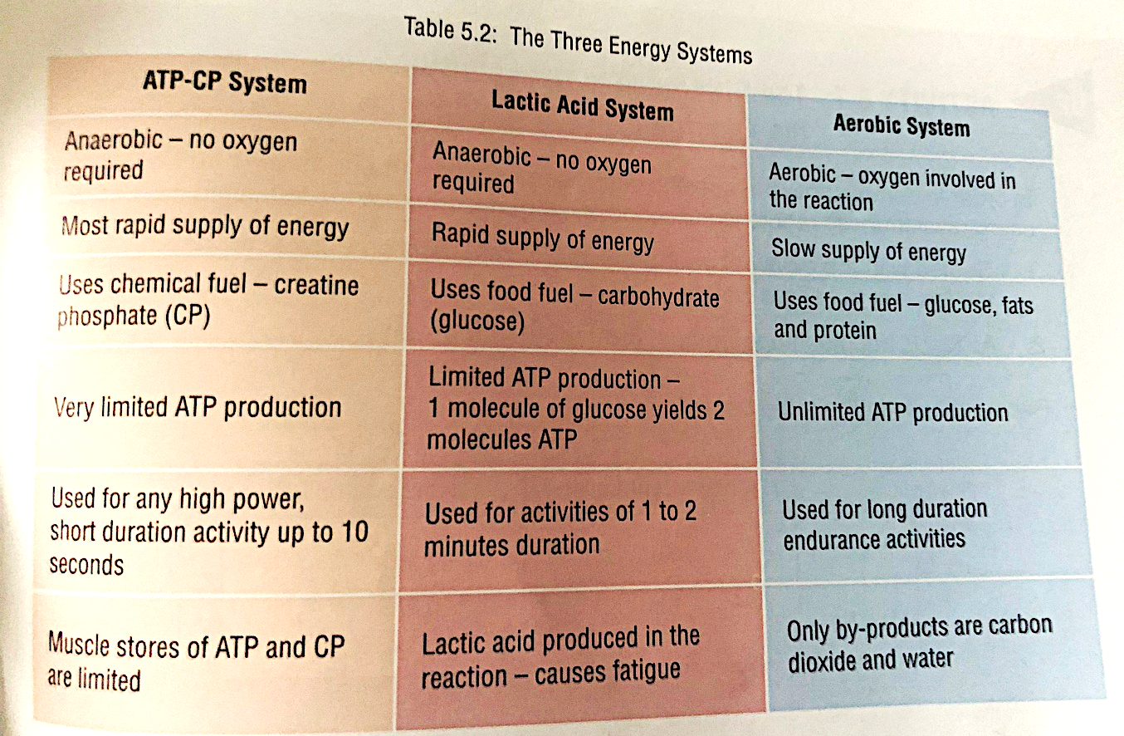
1 mark per energy system/ 1 mark per characteristic (3 total per system) (12)

- What are the main fuel source for each energy system?
1 Mark per correct answer (3)
- Carbohydrates
- Fats
- Proteins

- Explain the process of ATP production that leads to the release of energy for movement.
(5)
1 mark per point.
- ATP stored in small amounts in muscle cells
- Releases energy during break down of ATP to ADP.
- Breaking phosphate bonds gives energy for muscles to use.
- Third phosphate release the immediate source of energy used by the muscle cells for work.
- Carbohydrates primary fuel source of ATP.
- Carbohydrates are broken into glucose, stored as glycogen in
- Fats are secondary fuel source for ATP
- Broken down into Triglycerides which are stored in the muscle.

- Consider a Tour de France cyclist and the training required for this event. Name the energy system the cyclist would develop and name the type of training required for such an event. Use your knowledge of fitness testing to assist you.
(4)

1 mark per point.
- Predominantly building on their aerobic energy system.
- Endurance event, using all three fuel courses, carbohydrates, fats and proteins
- Cardiorespiratory endurance- build stamina for continuous physical activity.
- Cardiorespiratory endurance training, long distance cycle training. Interval training.
- muscular endurance- build muscles ability to continuously exert force repeatedly over time. Maintaining consistent cycle pace over long period of time.
- Power/ speed- for sprint sections of the cycle if overtaking.

